***LIBRARY MANAGEMENT SYSTEM***

SUBMITTED BY: SUBMITTED TO:

SANCHAL JAIN(RA2011031010072) DR THENMALAR

ANSHUL TOSHNIWAL(RA2011031010081)

PRATEEK JAIN(RA2011031010082)

SANSKAR BOHORA(RA2011031010111)

Department of Networking and Communications

SRM Institute of Science and Technology, Chennai – 603 203

ABSTRACT:

# Library is a collection of sources of information and similar resources, made accessible to a defined community for reference or borrowing. Thus, the process of handling a library manually is very troublesome and clumsy. As regards to this point of view, we plan to develop a computerized system for handling the activities of library management in a comprehensive way to lessen physical labor and reduce complexity of the manual system. In this project, we plan on adding many features which are generally not available in a library management system. It will have features like user login, faculty login and admin login. It will also have a facility where student after logging in their accounts can see list of books issued and its issue date and return date and also the students can request the librarian to add new books through a request link. Overall this project is being developed to help the students as well as staff of library to maintain the library in the best way possible and also reduce the human efforts.

1. **INTRODUCTION**

1.1 PURPOSE • The purpose of this project is to provide a friendly environment to maintain the details of books and library members. • The main purpose of this project is to maintain easy circulation system using computers and to provide different reports. • The Library System is a package to be used by Libraries to improve the efficiency of Librarians, Library employees and Users. • The system provides books catalogue and information to members and helps them decide on the books to borrow from the library. • The Librarian can keep the books catalogue updated all the time so that the members (students and the professors) get the updated information all the time.

1.2 SCOPE • The document only covers the requirements specifications for the Library Management System. • This document does not provide any references to the other component of the Library Management System. • All the external interfaces and the dependencies are also identified in this document. • The overall scope of the feasibility study is to provide sufficient information to allow a decision to be made as to whether the Library Management System project should proceed and if so, its relative priority in the context of other existing Library Management Technology •

# RELATED WORK

Publications about open-source E-Library software programmes are widely available. Even so, these publications emphasise user happiness while providing a general overview of the distinctions between software products that are open-source and those that are customised, as well as information on frequen problems and strategies connected to the integrated library system field. The report also provides an overview of E-library software packages for operating systems. An excellent account of library automation. Cargile an

HTML programmer and librarian, explained to her guests how to download, install, configure, and test MyPhpLibrary, one of the open-source software programmes. The essay's conclusion, which is implied, suggests that independent system implementation by librarians in smaller libraries would be dangerous. Numerous tactics, like intensive lectures, hands-on workshops, or hiring more computer staff, could be successful.Multiple open-source integrated library operating systems software were taken into consideration by Chalon et al. for this particular collection of libraries. The authors' method for selecting, evaluating, and employing the software was described in the study. The study also includes helpful discussions on how they went about seeking assistance or the difficulties they encountered.

For managing personal collections, there are a number of intriguing open-source software programmers available, like Tellico and GCstar But this kind of software package is not included in this research

# SYSTEM OVERVIEW

A library management system is software that is designed to manage all the functions of a library. It helps librarian to maintain the database of new books and the books that are borrowed by members along with their due dates.

This system completely automates all your library’s activities. The best way to maintain, organize, and handle countless books systematically is to implement a library management system software.

A library management system is used to maintain library records. It tracks the records of the number of books in the library, how many books are issued, or how many books have been returned or renewed or late fine charges, etc.

You can find books in an instant, issue/reissue books quickly, and manage all the data efficiently and orderly using this system. The purpose of a library management system is to provide instant and accurate data regarding any type of book, thereby saving a lot of time and effort.

# SYSTEM DESIGN MEHODS AND MATERIAL

In software engineering, a system development methodology refers to the framework that is used to structure, plan, and control the process of developing an information system. Software development methodologies define the processes we use to build software. These methodologies are also referred to as Software Development Process Models. Each methodology follows a series of steps unique to its type, to ensure success in the process of software development. A software process is a set of related activities that leads to the production of a software product. There are a lot of software processes but they all include four activities: ¬ Specification ¬ Development International Journal of Computer Applications (0975 – 8887) Volume 182 – No. 13, September 2018 19 ¬ Validation ¬ Evolution These are fundamental to software engineering. A wide variety of Software Development methodology has evolved over the years. Each of these methodologies has its own recognized strengths and weaknesses. The following are the most widely used methodologies for software development. 2.1.1 Waterfall Method The waterfall model is a sequential approach, where each fundamental activity of a process represented as a separate phase, arranged in linear order. This model requires planning and scheduling activities before starting working on them, it is plan-driven. Plan-driven process is one in which all the activities are first planned, and then each progress is measured against the plan. The Agile process on the other hand involves planning incrementally and it is much easier to change the processes to reflect a change in requirement. 2.1.2 Incremental Method The Incremental method of development is based on the idea of developing an initial implementation, exposing this model to user to receive feedback. This model evolves in the form of versions as the requirements change until an acceptable system has been developed. 2.1.3 Spiral Method The spiral model is a risk-driven method where the process is represented as spiral rather than a sequence of activities and it includes best features from the waterfall and prototyping models. In addition, it introduces a new component called: risk-assessment. Each loop in the spiral represents a phase, thus the first loop might be concerned with system feasibility. The next loop might be concerned with the requirements definition and the next with system design, and the like. 2.1.4 Prototyping Method A prototype is a version of a system or part of the system that’s developed quickly to check the customer’s requirements or the feasibility of some design decisions. Prototypes are useful when a customer or the developer is not sure of the requirements, the algorithms efficiency, some business rules or even response time. The four basic process activities of specification, development, validation, and evolution are organized differently in the respective development processes. In the waterfall model, they are organized in sequence, but are interleaved in incremental development method. The type of software, the people, and organizational structures involved determines how these activities are carried out. For example, specifications for extreme programming are written on cards. Tests are executable and developed before the program itself. Evolution may involve substantial system restructuring or re-factoring. This project uses the Incremental method in developing the application because the preferences of the users keep changing

1. **TECHNOLOGY AND TOOLS USED**

In this project, a number of development tools would be used to complete this project. They are listed as follow. Php PHP (recursive acronym for PHP: Hypertext Preprocessor) is a widely-used open source general-purpose scripting language that is especially suited for web development and can be embedded into HTML. The best things in using PHP are that it is extremely simple for a newcomer, but offers many advanced features for a professional programmer. Don't be afraid reading the long list of PHP's features. You can jump in, in a short time, and start writing simple scripts in a few hours. What distinguishes PHP from something like client-side JavaScript is that the code is executed on the server, generating HTML which is then sent to the client. The client would receive the results of running that script, but would not know what the underlying code was. You can even configure your web server to process all your HTML files with PHP, and then there's really no way that users can tell what you have up your sleeve. HTML HTML (Hypertext Markup Language) is the code that is used to structure a web page and its content. HTML is used to specify whether a web content should be recognized as a paragraph, list, heading, link, image, multimedia player, form, or one of many other available elements or even a new element that you define. It is the globally accepted programming language for formatting web pages. It is mostly used by small and medium scale businesses that do not really need advanced functionality on their websites. HTML is free, supports all browsers on the client’s machine, easy to use and understand hence, the choice in building the structure of my web pages. CSS Cascading Style Sheets (CSS) is a stylesheet language used to describe the presentation of a document written in HTML or XML (including XML dialects such as SVG or XHTML). CSS describes how elements should be rendered on screen, on paper, in speech, or on other media. CSS is one of the core languages of the open web and is standardized across browsers according to the W3C (World Wide Web Consortium) specification. JavaScript JavaScript is a high-level, dynamic, weakly typed, prototype-based, multi-paradigm, and interpreted programming language. JavaScript is a full-fledged dynamic programming language that, when applied to an HTML document, can provide dynamic interactivity on websites. It would be used in conjunction with Django to ensure validation rules on the front-end of the websites. Bootstrap Bootstrap is a free and open-source front-end web framework for designing websites and web applications. It contains HTML and CSS based design templates for typography, forms, buttons, navigation and other interface components, as well as optional JavaScript extensions. Unlike many web frameworks, it concerns itself with front-end development only. Bootstrap would be used to design the styling of the application alongside CSS. Bootstrap is important in the application for the following reasons: ¬ Easy to use: Anybody with just basic knowledge of HTML and CSS can start using Bootstrap. ¬ Responsive features: Bootstrap's responsive CSS adjusts to phones, tablets, and desktops. ¬ Mobile-first approach: Mobile-first styles are part of the core bootstrap framework. ¬ Browser compatibility: Bootstrap is compatible with all modern browsers (Chrome, Firefox, Internet Explorer, Safari, and Opera). Photoshop Adobe Photoshop is the predominant photo editing and International Journal of Computer Applications (0975 – 8887) Volume 182 – No. 13, September 2018 21 manipulation software on the market. Its uses ranges from full featured editing of large batches of photos to creating intricate digital paintings and drawings that mimic those done by hand. It is a graphic designing tool that enables picture manipulation and editing. Photoshop would be used to design user interfaces and the various images that would be required in developing the system.

FIG 1: Architecture Diagram

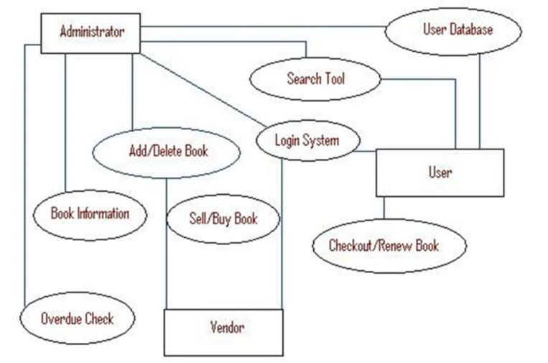

Fig 1: Architecture Diagram

1. **IMPLEMENTATION**

Figure 2 depicts the login interface for the Training and Placement Module System. By utilizing this login form, users may log into the system.

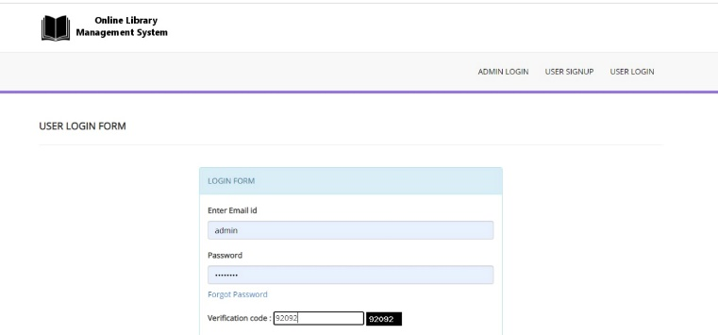

Fig 2: Login page

Figure 3 describes the homepage ,students can view and update their profile details in the page

Fig 3: Homepage

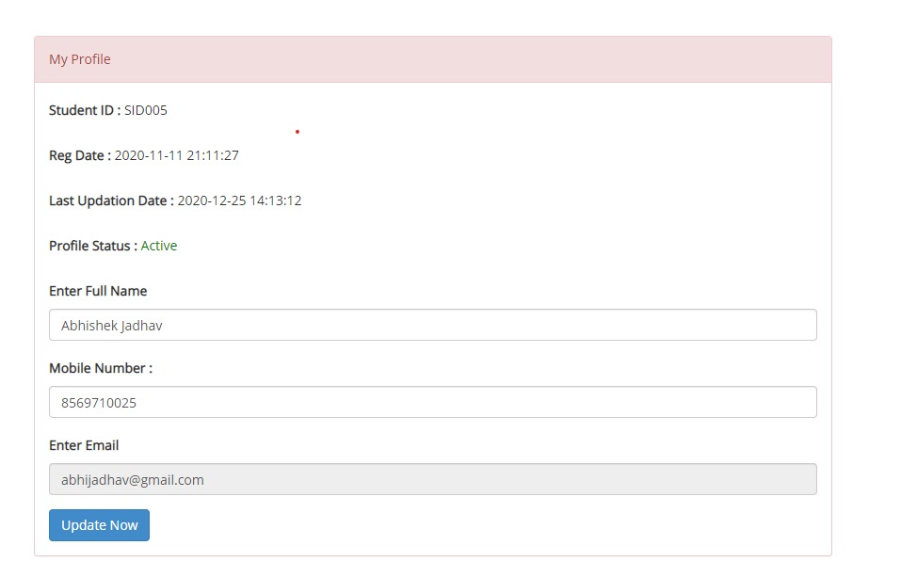

Figure 4 Students can view all the books (available/unavailable)

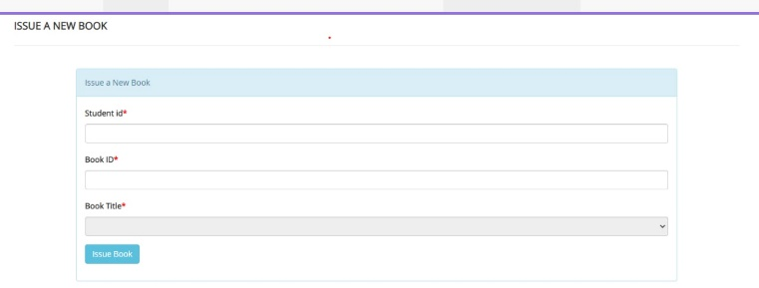

Fig:5

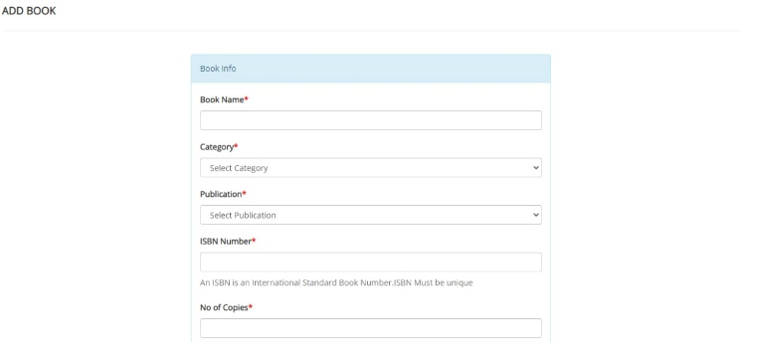

Fig 5: - ADD BOOK (User list)

As shown in Figure 6 DTE can see all the colleges that are listed under the University. DTE can add any new college and edit the existing ones as well.

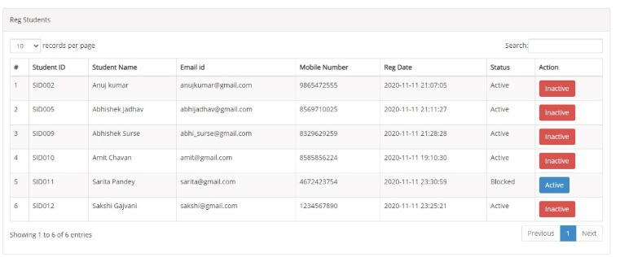

Fig 6: - registered students(college list)

In Figure 7: Manage books

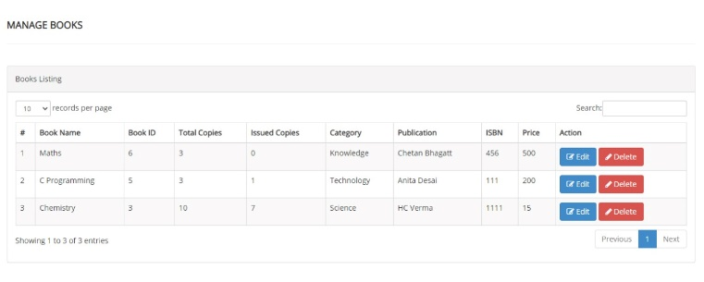

Fig 7: - Manage books

In Figure 8: Admin Dashboard

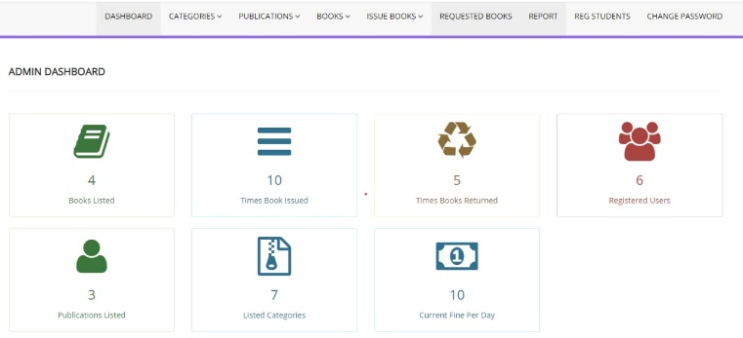

FIG 8: Admin Dashboard

1. **RESULT AND DISCUSSION**

After the system developed, process of system testing must be carry on in order to test if the system is free of bugs. If during the system testing, there are bugs or errors detected, the developer may need to correct and fix the bugs immediately. Testing is the process of evaluating a software or system to detect differences between given input and expected output. Testing is conducted to assess the quality of a system hence can be said to be a validation and verification process. This ensures that system meets the technical requirements that guided its design and development, works as expected and can be implemented with the same characteristics. There are few types of system testing that must be performed which include the unit testing, integration testing, system testing, and acceptance testing. System testing is not a testing that is limited only to the development team but it also requires the help from specific outsider (beta-tester) to test on the system acceptance.

# CONCLUSION

The Internet has become a major resource in modern life, thus library management system has gained significance not only from the management staff but also from the student’s point of view. For the management, library system generates new books opportunities and for the student, it makes comparative selecting possible. As per a survey, most students of online library system are impulsive and usually make a decision to stay on a site within the first few seconds. Website design is like a management interior. If the management looks poor or like hundreds of other management the student is most likely to skip to the other site. Hence, the project has been designed to provide the user with easy navigation, retrieval of data and necessary feedback as much as possible

# REFERENCES

[1]https://www.vendorview360.com/reference-library-mana gement/

[2]https://www.uef.fi/en/web/kirjasto/tietoa-kirjastosta/johta minen

[3][https://www2.illinois.gov/cdb/business/library/Document s/DCM2006.pdf](https://www2.illinois.gov/cdb/business/library/Document%20s/DCM2006.pdf)

[4]<http://thereferencelibrary.com/design_professionals/design_professionals.php>

[5] <http://thereferencelibrary.com/>

[6] Nige, B. (2018, January 15). Why Django? Retrieved from Django Book: https://djangobook.com/tutorials/why-django/

[7] Rajkumar. (2018, April 05). Software Architecture: One-Tier, Two-Tier, Three Tier, N Tier. Retrieved from SoftwareTestingMaterial: [https://www.softwaretestingmaterial.com/software-archit ecture/](https://www.softwaretestingmaterial.com/software-archit%20ecture/)

[8] Sheppy. (2018, January 17). CSS: Cascading Style Sheets. Retrieved from MDN web docs: https://developer.mozilla.org/en-US/docs/Web/CSS [9] SmartDraw. (2018, April 09). Entity Relationship Diagram. Retrieved from SmartDraw: https://www.smartdraw.com/entity-relationship-diagram/ [10] Smith, L. (2018, January 25). What PostgreSQL has over other open source SQL databases: Part I. Retrieved from Compose: https://www.compose.com/articles/what-postgresql-has-o ver-other-open-source-sql-databases/ [11] studytonight. (2018, April 09). Normalization of Database. Retrieved from studytonight: https://www.studytonight.com/dbms/database-normalizat ion.php [12] Team, P. C. (2017, November 23). 7 Key Features Online Shoppers Demand From an Online Store. Retrieved from PinnacleCart: https://www.pinnaclecart.com/blog/7-key-features-online -shoppers-demand-from-an-online-store/ [13] The Editors of Encyclopaedia Britannica. (2018, April 06). Database. Retrieved from Britannica: https://www.britannica.com/technology/database [14] Wikipedia. (2018, April 09). User interface design. Retrieved from Wikipedia: https://en.wikipedia.org/wiki/User_interface_design